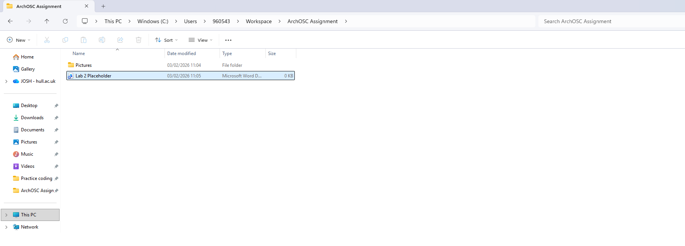
Then I opened my folder within the terminal (directly through folder) before using the git init command to create a local repository allowing me to edit my work in an external environment
I took a screenshot of my newly created folder(titled ArchOSC Assignment) for lab 2 including a clear showcase of the path to reach said folder and the contents inside.
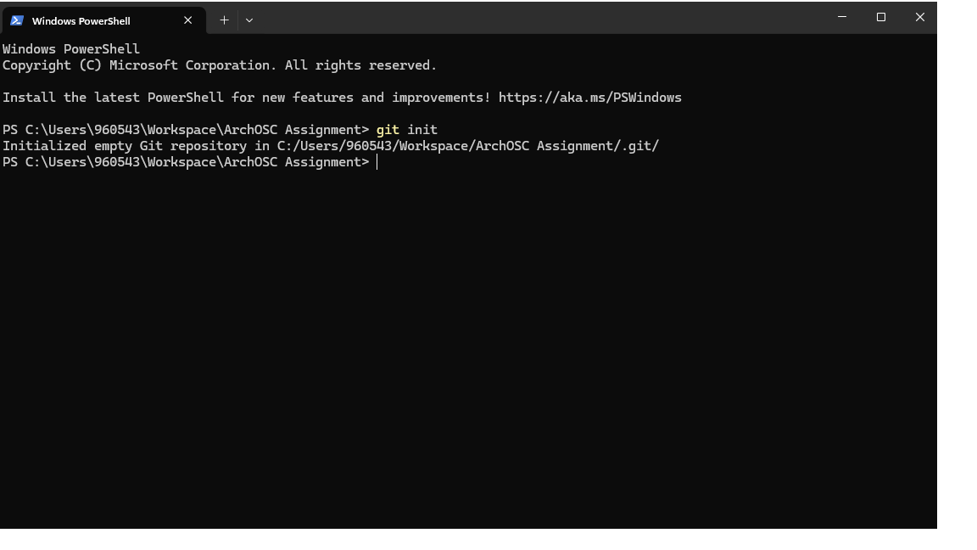

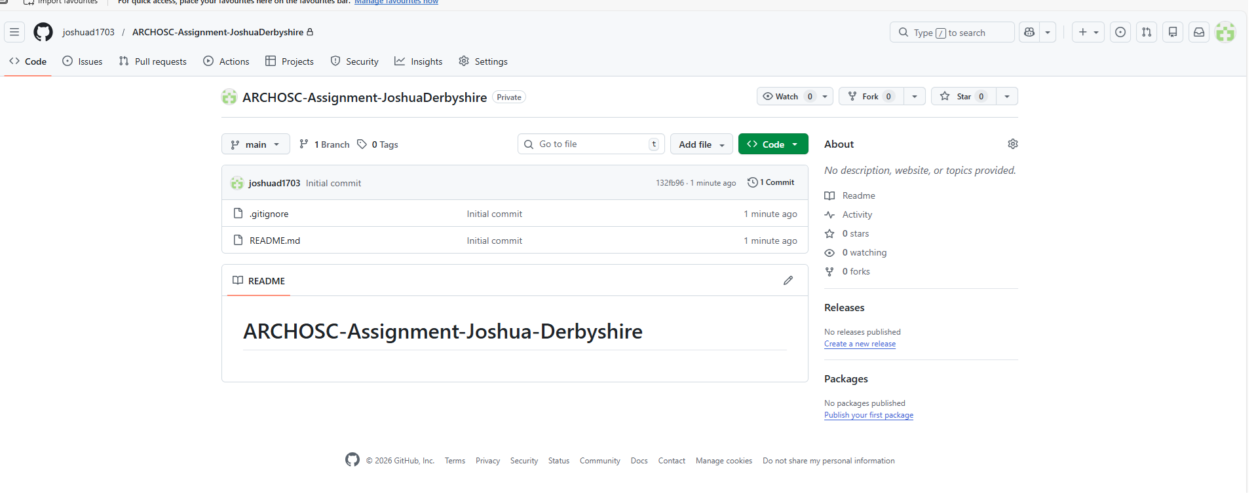
After creating a repository locally , I then had to create a second repository on GitHub in order to create a place for me to push any edits made locally ,following the restrictions required( added ReadMe and .gitignore)

